 | HOLY CROSS COLLEGE  SEMESTER 1, 2017  Question/Answer Booklet

Please place your student identification label in this box
11 PHYSICS

Student Name ___________________________________

Student’s Teacher __________________________________________

Time allowed for this paper
Reading time before commencing work: 10 minutes
Working time for paper: 3 hours

Materials required/recommended for this paper

To be provided by the supervisor
This Question/Answer Booklet
Multiple-choice Answer Sheet
Data Sheet

To be provided by the candidate
Standard items: pens, pencils, eraser, correction fluid, ruler, highlighters
Special items: non-programmable calculators satisfying the conditions set by the School Curriculum and Standards Authority for this course

Important note to candidates
No other items may be taken into the examination room. It is your responsibility to ensure that you do not have any unauthorised notes or other items of a non-personal nature in the examination room. If you have any unauthorised material with you, hand it to the supervisor before reading any further.

Structure of this paper

Section | Number of questions available | Number of questions to be answered | Suggested working time  (minutes) | Marks available | Percentage of exam
Section One:  Short Answers | 15 | 15 | 60 | 61 | 38
Section Two:  Problem-solving | 6 | 6 | 90 | 80 | 50
Section Three:  Comprehension | 1 | 1 | 30 | 20 | 12
 |  |  |  | 161 | 100

Instructions to candidates

1. The rules for the conduct of examinations at Holy Cross College are detailed in the College Examination Policy. Sitting this examination implies that you agree to abide by these rules.

2. Write your answers in this Question/Answer Booklet.

3. Working or reasoning should be clearly shown when calculating or estimating answers.

4. You must be careful to confine your responses to the specific questions asked and to follow any instructions that are specific to a particular question.

5. Spare pages are included at the end of this booklet. They can be used for planning your
responses and/or as additional space if required to continue an answer.

• Planning: If you use the spare pages for planning, indicate this clearly at the top of the
page.
• Continuing an answer: If you need to use the space to continue an answer, indicate in
the original answer space where the answer is continued, i.e. give the page number.
Fill in the number of the question(s) that you are continuing to answer at the top of the
page.

6. Answers to questions involving calculations should be evaluated and given in decimal
form. It is suggested that you quote all answers to three significant figures, with the
exception of questions for which estimates are required. Despite an incorrect final result,
credit may be obtained for method and working, providing these are clearly and legibly set
out.

7. Questions containing the instruction "estimate" may give insufficient numerical data for their
solution. Students should provide appropriate figures to enable an approximate solution to
be obtained. Give final answers to a maximum of two significant figures and include appropriate units where applicable.

8. Note that when an answer is a vector quantity, it must be given with magnitude and direction.

9. In all calculations, units must be consistent throughout your working.
SECTION ONE: Short Answers

Marks Allotted: 61 marks out of 161 total.

Attempt ALL 15 questions in this section. Answers are to be written in the space below or next to each question.

1. Perform the following conversions to standard units of kilograms, metres and seconds.
(4 marks)

(a) 4.7 x 10³ mm (b) 791000 g

(c) 41.7 cm² (d) 6.39 x 10⁴ days

2. Below is a graph showing the distribution of kinetic energy of particles for two different samples of zinc that are at two different temperatures.
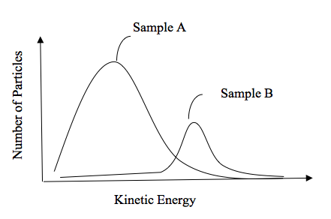
(a) Which of the two samples of zinc would have the higher temperature? Explain your choice. (2 marks)

(b) Which is likely to have greater internal energy – an indoor swimming pool that has been heated to 28 °C or a stainless steel paper clip heated to 1,100 °C? Explain your answer. (2 marks)

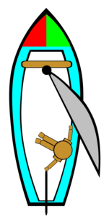

3. Stephen is sailing a boat North at 5.50 ms⁻¹ when he enters a
current travelling East at 1.50 ms⁻¹. Calculate Stephen’s resultant
velocity once he enters the current. You must state the magnitude
and direction of his resultant velocity.
(4 marks)

4. During a Myth Buster's programme investigating ballistics, a 1.75 g bullet is analysed by a high-speed video. It enters a pine board at a speed of 2.90 x 10² ms⁻¹ and emerges out of the other side at 1.10 x 10² ms⁻¹. Calculate the work done by the board on the bullet.
(4 marks)

5. A basketball of mass 624 g is dropped onto concrete, striking it at 4.20 ms⁻¹ and rebounding at 2.30 ms⁻¹. Calculate the ball's:

(a) change in velocity. (2 marks)

(b) change in momentum. (2 marks)

6. An electric kettle with a rating of 3.00 x 10² W takes 2.50 minutes to heat water from 25.0 °C to 70.0 °C. Calculate how much water was in the kettle. (Assume the transfer of energy is 100% efficient and the kettle absorbs negligible energy.) (4 marks)

7. During a golf tournament, a player used the driver to hit a 45.9 g golf ball off the tee in the ground. The stationary ball moves to 70.0 ms⁻¹ in 4.00 x 10⁻⁴ s. Calculate the force exerted by the club onto the ball.
(4 marks)

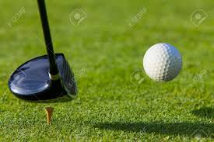

8. During an Olympic power-lifting event, Ryan manages to snatch 140.0 kg from the floor to 2.10 m above the floor (and over his head) in a total time of 1.80 s. Determine the average power generated by Ryan during this lift. (3 marks)

9. (a) Just before she serves a ball in a tennis match, Serena Williams throws the ball towards the ground with an initial velocity of 3.00 ms⁻¹. If she releases the ball 1.10 m above the ground, with what velocity does it hit the ground? (3 marks)

(b) If the ball has a mass of 59.4 g, what is its total energy as it hits the ground?
(3 marks)

10. (a) Explain why heat transfer by conduction is more effective in liquids than in gases. (2 marks)

(b) Explain why aluminium is a better conductor of heat than phosphorus, despite the fact that both are solids at room temperature and they have similar atomic masses.
(2 marks)

11. At the end of the Apollo 15 moonwalk, Commander David Scott dropped a 1.32 kg geologic hammer and a 0.030 g falcon feather from a height of 1.60 m above the surface of the moon. He observed that when the feather and the hammer were dropped simultaneously, they both impacted the surface of the moon at the same time. Explain this observation.
(3 marks)

12. An elevator carrying four passengers has a total combined mass of 2.00 x 10³ kg. It is moving upwards and decelerates at 1.20 ms⁻² to stop at the twelfth floor. Calculate the tension in the cable holding the elevator as it decelerates.
(4 marks)

13. Two bumper cars in an amusement park collide head-on. One has a mass of 4.50 x 10² kg and is moving at 4.50 ms⁻¹, while the other has a mass of 5.50 x 10² kg and is moving at
3.70 ms⁻¹. If the heavier vehicle rebounds at 0.500 ms⁻¹, calculate the final velocity of the lighter vehicle. (5 marks)

14. A plane flying due north from Perth at 8.70 x 10² kmh⁻¹ has to contend with a wind of
1.10 x 10² kmh⁻¹ heading northwest. Draw a suitable vector diagram and determine the plane's resultant velocity (in kmh⁻¹) over the ground. (5 marks)

15. A force is applied to an object over a short period of time as shown in the graph below. Use the graph to determine the impulse acting on the object. (3 marks)
F (N)
3.0
0.05
0.10
0.15
t (s)

THIS PAGE HAS BEEN DELIBERATELY LEFT BLANK.

SECTION TWO: Problem Solving

Marks allotted: 80 marks out of 161 marks total.

Attempt ALL 6 questions in this section. The marks allocated to each question are given and the answers should be written in the spaces provided.

(16 marks)

16. A motorbike, which is initially travelling at a 10.0 ms⁻¹ along a straight road, accelerates to 30.0 ms⁻¹ in 6.0 s. It maintains this velocity for 15.0 s before braking uniformly for 5.0 s, reducing speed to 15.0 ms⁻¹. It continues for another 10.0 s before braking uniformly to a stop in 4.0 s.

(a) Draw a velocity-time graph for the motion of the motorbike, including scales and labels on the axes. (Assume the motion is in a straight line.) (4 marks)

(b) From the graph, determine the distance for the entire motion.
(5 marks)

(c) Draw an acceleration – time graph of this motion, giving clear scales on each axis. You may need to do some calculations. Use the spare pages at the end of this answer booklet. (7 marks)

(14 marks)

17. A roller coaster of total mass 8.73 x 10³ kg is pulled by a mechanical track up to the top part of the track as shown below. It takes 22.0 seconds to reach the top and is moving at
2.00 ms⁻¹ at point A.

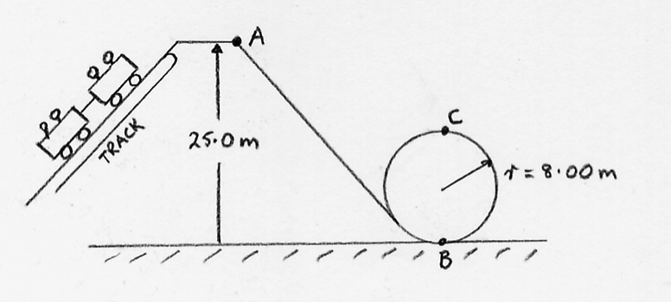

(a) Calculate the total energy of the roller coaster at point A. (3 marks)

(b) What is the average power of the motor driving the track that lifts the roller coaster to point A. (2 marks)

(c) How fast would the roller coaster travel at point B? (3 marks)

(d) Theoretically, the minimum speed required to safely make it through point C is
8.85 ms⁻¹. If the designers of the ride have built in a “safety margin”, determine:

(i) the speed at point C. (4 marks)

(ii) the safety margin built in, expressing the answer as a percentage. (2 marks)

(12 marks)

18. In a laboratory investigation of Newton's Second Law, a group of students applied forces of differing sizes onto an object. Each force was applied for a time of 1.20 s. The students measured the change in velocity of the object for each trial. The results are given below.

Force  (N) | Change in Velocity (ms⁻¹)
0 | 0
1.6 | 1.8
3.1 | 3.5
4.9 | 5.8
7.8 | 8.9
11.3 | 13.0
15.4 | 17.5

(a) Graph these results on the graph paper provided. Draw the line of best fit.
(HINT: Graph "change in velocity" on the x-axis.) (4 marks)

(b) Calculate the gradient of the line of best fit. (4 marks)

(c) Use the gradient to determine the mass of the object. (4 marks)

Note: A spare graph paper is at the back of the booklet if you need it.

(17 marks)

19. To investigate the properties of salt water, Lia heated 325 g of frozen salt water at -15.0 °C to a temperature of 115 °C in an insulated container. Her results are shown in the heating curve below.

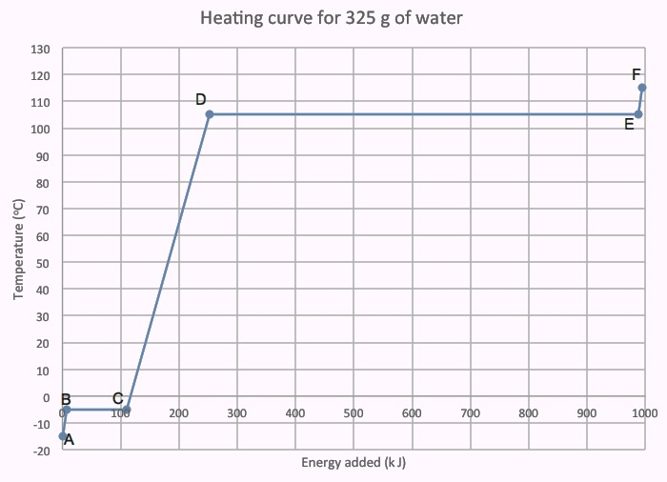
(a) Label the graph to identify the phases of the salt water. (3 marks)

(b) Explain why the temperature of the salt water is constant between points D and E. You must refer to the kinetic particle model and the internal energy of the salt water.
(4 marks)

(c) Why is the plateau DE much longer than BC? (2 marks)

(d) (i) How much heat is absorbed by the salt water in DE? (1 mark)

(ii) Use your answer to (c) (i) above to determine the latent heat of vaporisation.
(3 marks)

(e) Calculate the specific heat of salt water from the graph. (4 marks)

(14 marks)
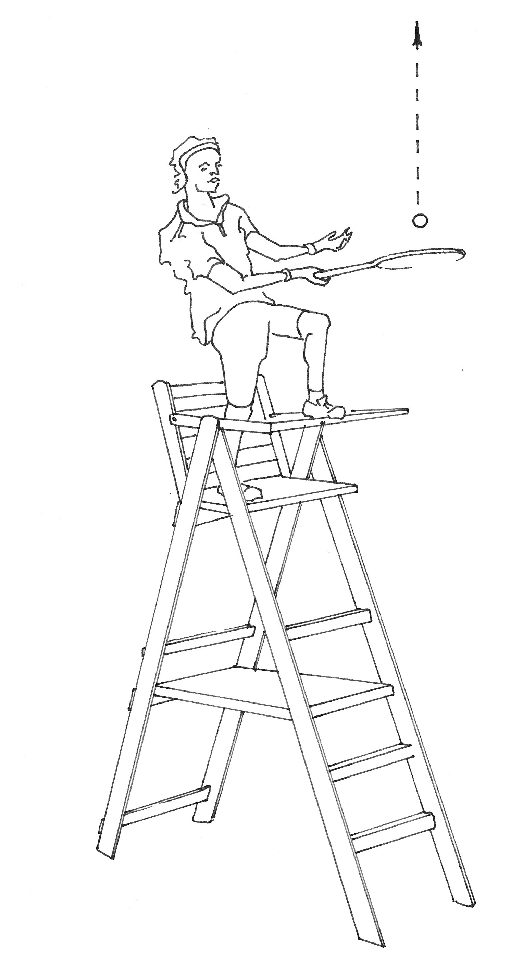
3.80 m
20. Andy Murray celebrates his Wimbledon victory by climbing onto the top of the umpire’s chair and smashing a tennis ball vertically upwards.

The ball is launched from a position 3.80 m above the ground with an initial velocity of 24.2 ms⁻¹ upwards.

The ball has a mass of 56.7 grams.

You may ignore air resistance in this question.

(a) Calculate the maximum height that the ball reaches above the ground. (4 marks)

(b) Determine the impact velocity of the ball with the ground. (3 marks)

(c) How long is the ball in flight? (2 marks)

(d) Draw a displacement-time graph for the motion of the ball. Include clear scales on each axis.
(5 marks)

(7 marks)

21. A 70.0 kg person is in a lift that is stationary at the thirtieth floor of a building. The lift uniformly accelerates downwards at 1.75 ms⁻² for 3.00 s before maintaining its speed. As it nears the ground floor, the lift decelerates uniformly at 2.00 ms⁻² to bring the lift to a stop.

(a) What is the apparent weight of the person as the lift starts to move down from the thirtieth floor? (4 marks)

(b) Determine the apparent weight when the lift is moving downwards with a constant speed. (3 marks)

THIS PAGE HAS BEEN DELIBERATELY LEFT BLANK.

SECTION C: Comprehension and Interpretation

Marks Allotted: 20 marks out of 163 marks total.

Read the passage carefully and answer all of the questions at the end. Candidates are reminded of the need for correct English and clear and concise presentation of answers. Diagrams (sketches), equations and/or numerical results should be included where appropriate.

(20 marks) Firewalking

Para 1
There has recently been a return to the craze of "firewalking". People are willing to pay large sums of money to be taught the secret of safely walking over red-hot coals. They are encouraged to undertake a period of spiritual purification beforehand. They are given an uplifting address by a charismatic teacher, then taken to see the fire lit. The claim that is over a "thousand degrees" seems fair. The fire seems very hot, much hotter than it really is for a very interesting reason. We are used to a heat source being a point source and as such, the inverse square law applies. If we double the distance we are from the heat source, the intensity is reduced by a factor of 4. We conclude that when we measured the heat a distance from the heat source, the heat at the actual site will be much greater. In fact, the firewalkers’ bed of flames is not a point source at all and the inverse square law does not apply. Thus, the observer gets a false impression of the temperature of the coals.

Para 2
The fire is left to get to an uniform temperature and the audience is given another uplifting talk, stressing the need for purity, determination and giving school, especially Physics, your very best. Then outside, off with the shoes and everyone follows the leader across the coals. The secret is to be quick, usually not more than a couple of seconds at the most. Much attention is given to the preparation of the fire. The red-hot embers are like fluffy bits of charcoal. They are certainly hot but contain very little heat energy since they are so light. Thus, when the bare foot touches the coal, very little heat energy is transferred. After a person has skipped across, black marks are clearly visible on the coals where the feet have been. In a moment, the marks vanish as the embers warm up when heat flows from the interior of the fire. Many people get small blisters but do not notice them since they are in a temporary trance. One unfortunate Physics student stood on the coals for ten seconds and had to be rushed to Joondalup Hospital with third degree burns.

Para 3
There is then no secret to firewalking. It is a straightforward demonstration of the basic ideas involved in Year 11 Physics. In a similar way, you know that when you take a meat pie out of the oven and eat it straight away, you burn your tongue, not on the pastry but the filling. When the pastry touches your tongue, heat energy is transferred from the hot pastry to your relatively cold (37 °C) tongue. The filling has much more heat energy than the pastry since it contains more fat and water, which has a high specific heat.

Para 4
In the Middle Ages, soldiers used to defend their castles by pouring oil at 300 °C onto the attackers. This proved a very effective defence mechanism, even though the specific heat of oil is approximately half that of water.

1. If the source was a point source like a potbelly stove or Bunsen burner, by what factor would the intensity be reduced when you are three (3) times as far away? (Para 1)
(1 mark)

2. You stupidly put your hand in an oven at 350 ºC and quickly removed it. Give two (2) Physics reasons why you would not be burnt. (Para 2) (2 marks)

3. Now you hold on to a metal tray in the same oven - why is the sensation different?
(2 marks)

4. What evidence is there that heat energy has been transferred in firewalking? (Para 2)
(2 marks)

5. What property do the red coals have that makes firewalking "safe"? Why does this property have this effect? (Para 2) (3 marks)

6. Why does a skilful firewalker move quickly? (Para 2) (1 mark)

7. You say to the firewalker: “I see that you can walk on hot coals that are 1000 °C for
5 seconds; would you please stand for 5 seconds on this electric hotplate.”
Suggest what the firewalker's considered response to this might be. (3 marks)

8. Why is it when you eat a meat pie that has been in the oven, the filling burns more than the crust? Are they both at the same temperature? (Para 3) (3 marks)

9. In the Middle Ages, defenders of castles used to pour boiling oil on to attackers. Explain why they used oil rather than water, using simple calculations to justify your answer. (3 marks)

END OF EXAMINATION
ADDITIONAL WORKING SPACE

ADDITIONAL WORKING SPACE

ADDITIONAL WORKING SPACE
ADDITIONAL WORKING SPACE

